# Logging in to Naviance (Staff and Students)

## **Go to** https://launchpad.classlink.com/cbsd

1. 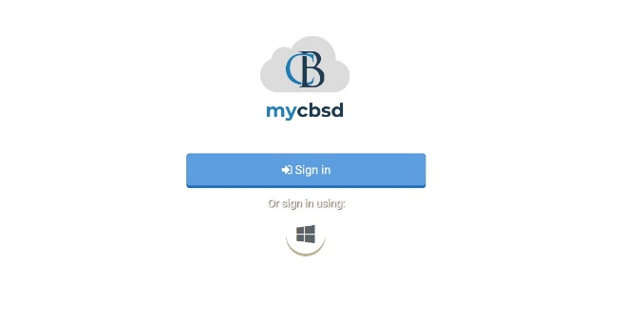Click the **Sign In button**
2. Enter your @CBSD.org staff email address, and password and click **Sign In**
3. Click on the **Naviance Icon**

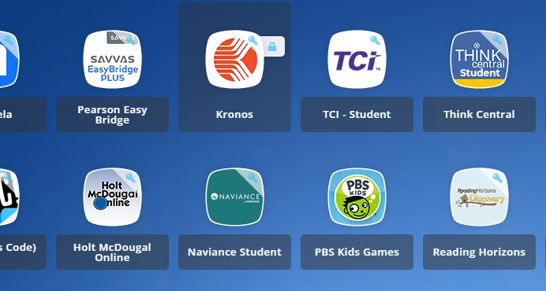

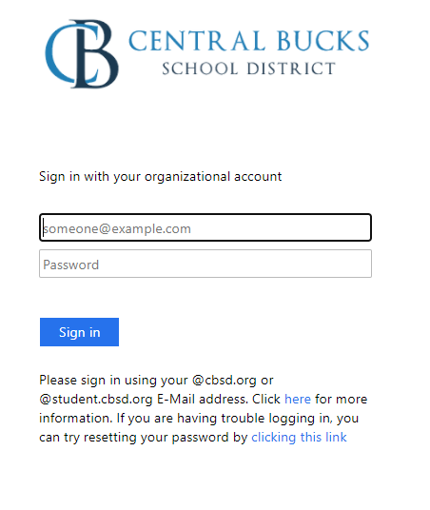You will then be logged into Naviance.

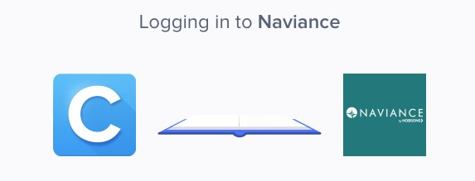



Eleventh Grade Scope and Sequence

# Game Plan Survey

1. From your Naviance Student homepage, click **My Planner** and then **Tasks** in the top right corner

1. From the Task page, click the task titled

### Game Plan Survey.

1. Locate the “completion trigger” in the top

right corner indicated by the pink arrow.



1. Click the text, **complete the Game Plan Survey** to go to the survey page.
2. Once you have answered all of the required questions

(marked by an asterisk and in red) click “Submit Answers”

at the bottom of the page.



1. Submitting the survey will mark the task as complete.

**Post-Secondary Goals Survey**

1. From your Naviance Student homepage, click **My Planner** and then **Tasks** in the top right corner.

1. From the Task page, click the task titled **Post-Secondary Goals Survey.**
2. Locate the “completion trigger” in the top

right corner indicated by the pink arrow.



1. Click the text, **complete the Post-Secondary Goals Survey** to go to the survey page.
2. Once you have answered all of the required questions

(marked by an asterisk and in red) click “Submit Answers”

at the bottom of the page.



1. Submitting the survey will mark the task as complete.

# Complete SuperMatch College Search

1. From your Naviance Student homepage, click **My Planner** and then **Tasks** in the top right corner

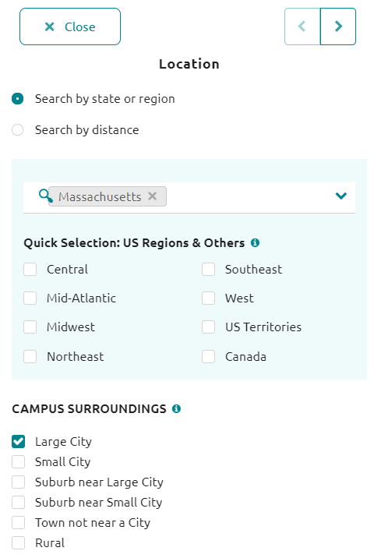

1. From the Task page, click the task titled

### Complete SuperMatch College Search

1. Locate the “completion trigger” in the top

right corner indicated by the pink arrow



1. Click the text, **search for colleges** to go to the SuperMatch College Search page
2. On the SuperMatch College Search page, use the **fit criteria** at the top of the screen



1. When each fit criteria box pops up (after clicking the fit criteria) enter your preferences. Click **Close** at the top left corner to add the fit criteria to your search
2. Move fit criteria from the Need to Have to the Nice to Have list by clicking the **arrow** next to fit criteria

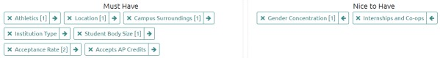

1. View your college matches by scrolling down the page, listed in order by fit under the header **Your Results**

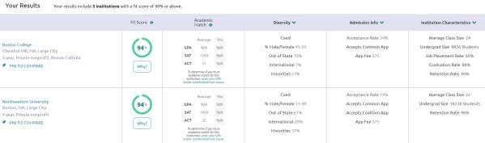

1. Once you view the search results, the task is marked complete!

**Add at Least Three College of Interest to the “Colleges I’m Thinking About” list**

1. From your Naviance Student homepage, click **My Planner** and then **Tasks** in the top right corner

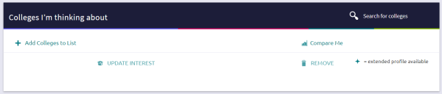

## 6. Use the College Quicklist, keyword look up, or other search tools to see a list of colleges you want to learn more about.

1. From the Task page, click the task titled **Add colleges to my list**
2. Locate the “completion trigger” in the top

right corner indicated by the pink arrow



1. Click the text, **add at least 1 college(s) to your list**

## On the Colleges I’m Thinking About page

click **Add Colleges to List** on the left

## Once you see a college you like, click the **Favorites** heart icon to save a college to your list



You can also use the check box next to several colleges and then save to your favorites list using the **Favorite** button



1. Complete the **Favorite** action above three times total to mark the task complete

# Build/Update Resume

1. From your Naviance Student homepage, click **My Planner** and then **Tasks** in the top right corner.

1. From the Task page, click the task titled **Build Resume.**
2. Locate the “completion trigger” in the top

right corner indicated by the pink arrow.



1. Click the text, **build a resume** to go to the Resume Builder tool.
2. On the Resume Builder page, click the pink circle and white arrow to add a section to your resume.



1. Add your information into the resume area you selected. When you are finished with each section click **Add.**
2. Once you’ve added all the sections you would like in this draft of your resume, click **Print/Export Resume** at the top of the screen.



1. Clicking the same pink circle and white arrow icon, add a resume draft. Name your draft and select a resume template.

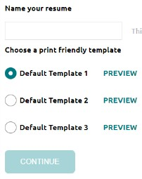

1. Select the resume sections you’d like to include in your draft using the check boxes. When complete click **Save Resume.**
2. A completed draft of your resume marks the task as complete